Mass Change CRDC Fields before Import
CRDC Reporting Date:
S_MI_STU_CRDC_X.crdcDate#
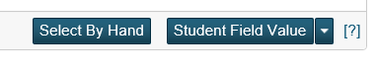
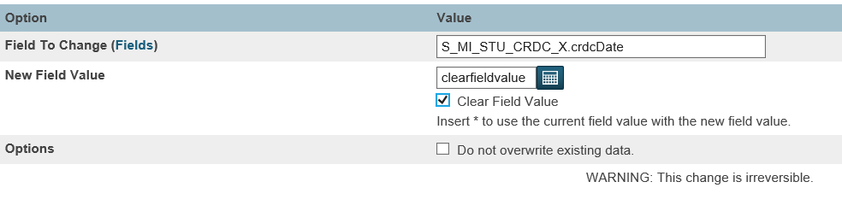

School Number:
S_MI_STU_CRDC_X.crdcSchool#
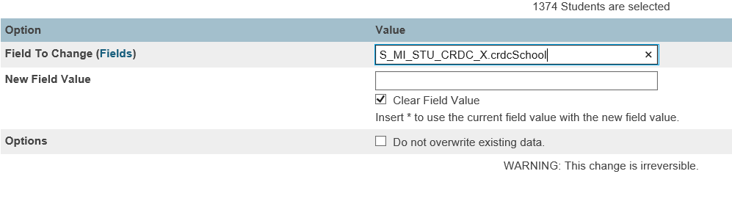

Entry Date:
S_MI_STU_CRDC_X.entryDate#
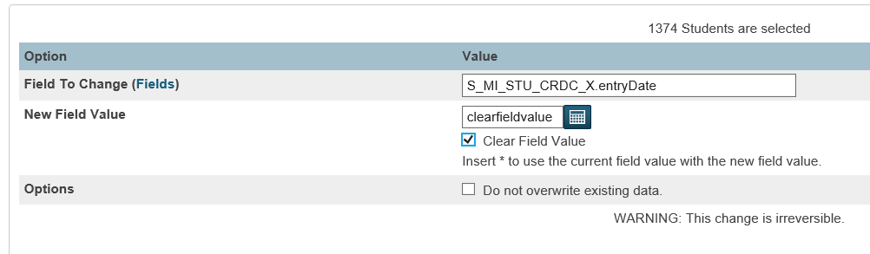

Exit date:
S_MI_STU_CRDC_X.exitDate#
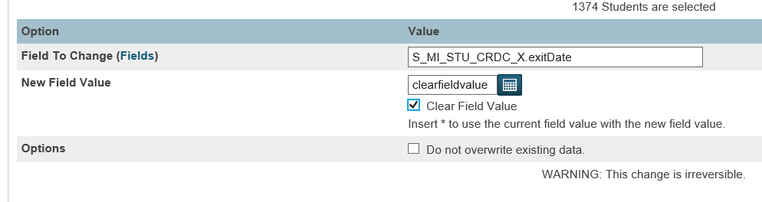

Grade Level:
S_MI_STU_CRDC_X.crdcGrade#
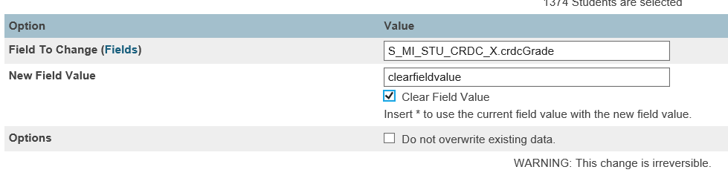

Developmental retention kindergarten program:
S_MI_STU_CRDC_X.devRetKinder_CD#
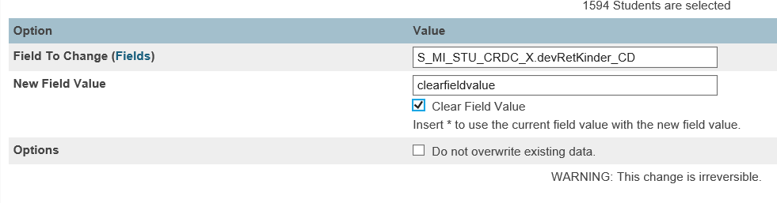

Early On student age zero (0) to three (3):
S_MI_STU_CRDC_X.earlyOn_CD#
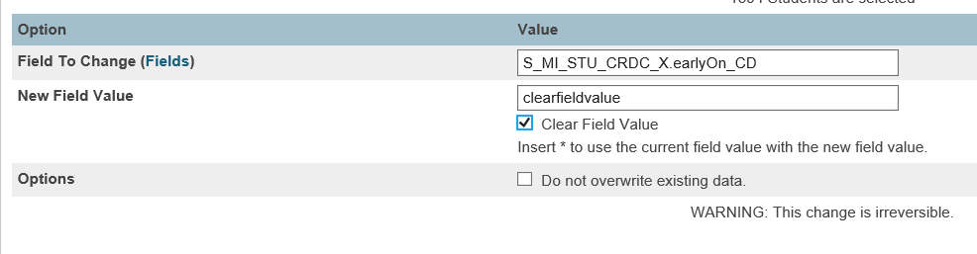

Gifted and talented program:
S_MI_STU_CRDC_X.gifted_CD#
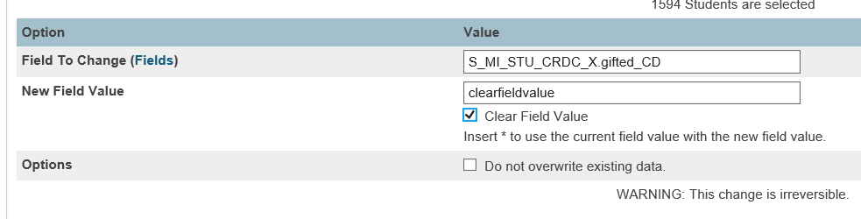

LEP program code:
S_MI_STU_CRDC_X.LEP_CD#
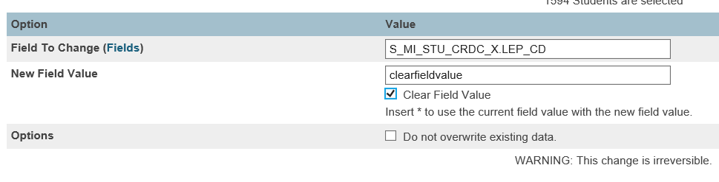

LEP program code:

S_MI_STU_CRDC_X.LEPProg_CD#

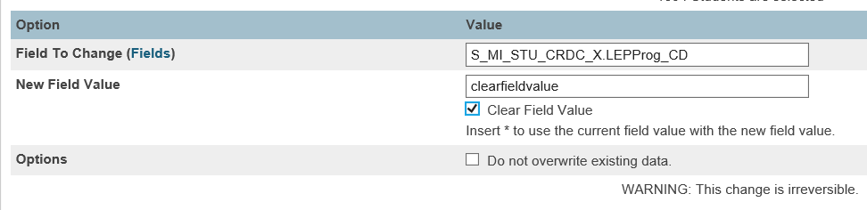

You can use the MISD CRDC Desktop Application to create a tab delimited text file from your Fall 2017 MSDS General Collection xml file and then import the results back into PowerSchool to update the Michigan CRDC+ section of the CRDC tab of the State/Province-MI page.

If you need a copy of your district’s Fall 2017 General Collection xml file, it can be downloaded from the state of Michigan CEPI MSDS application.

Important Note!
The MISD Desktop Application process is a one-time process for the 2017-18 CRDC submission cycle.
The MI CRDC Snapshot Date Data process will be used to populate the Michigan CRDC+ section of the CRDC tab in the future.

Run the MISD CRDC Desktop Application
To run the MISD CRDC Desktop Application, go to the following web address:
http://powerschool.misd.net > State > Civil Right Data Collection-CRDC

Click on the link for the MISD CRDC Desktop Application.

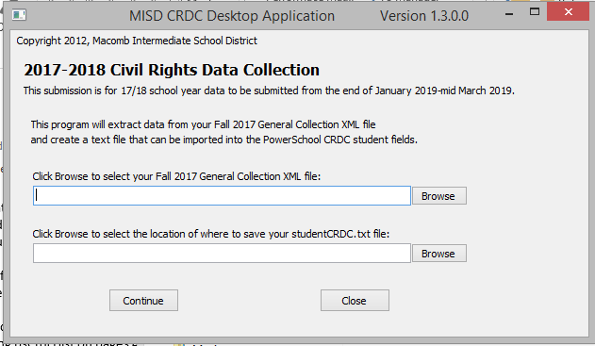

Once the program opens:

Click the top Browse button to find and select your Fall 2017 MSDS General Collection file.
Click the bottom browse button to select the location to save the studentCRDC.txt file.
Click continue to create the text file.
A message will appear when the file has been created.
Click OK to continue.
We do not recommend opening or reviewing the file prior to importing back into PowerSchool. Opening the file could potentially add additional characters or create formatting issues that could cause errors when importing the file back into PowerSchool. If you want to open the file and review it, please do not save the file when closing.

Import the MISD CRCD Desktop Application File
Start Page > Special Functions > Importing and Exporting > Quick Import

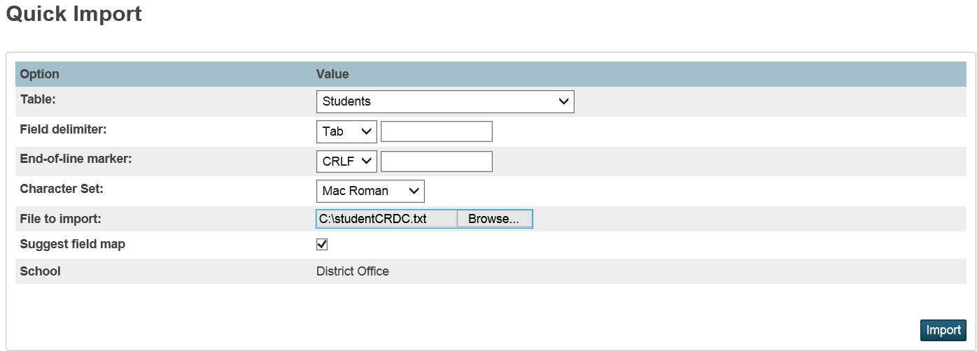

Quick Import
Table: select the Students table
Field Delimiter: Tab
End-of-line marker: select CRLF
Character Set: leave as Mac Roman
File to Import: browse to the studentCRDC.txt file
Suggest Field Map: make sure this box is checked
Import

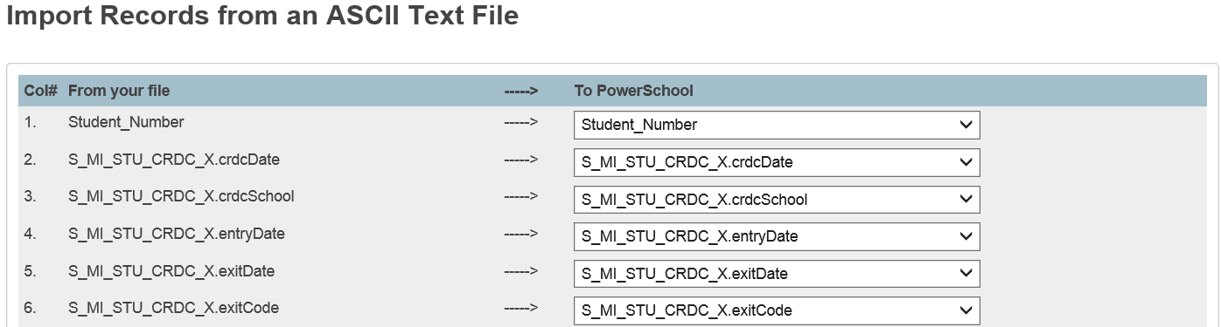
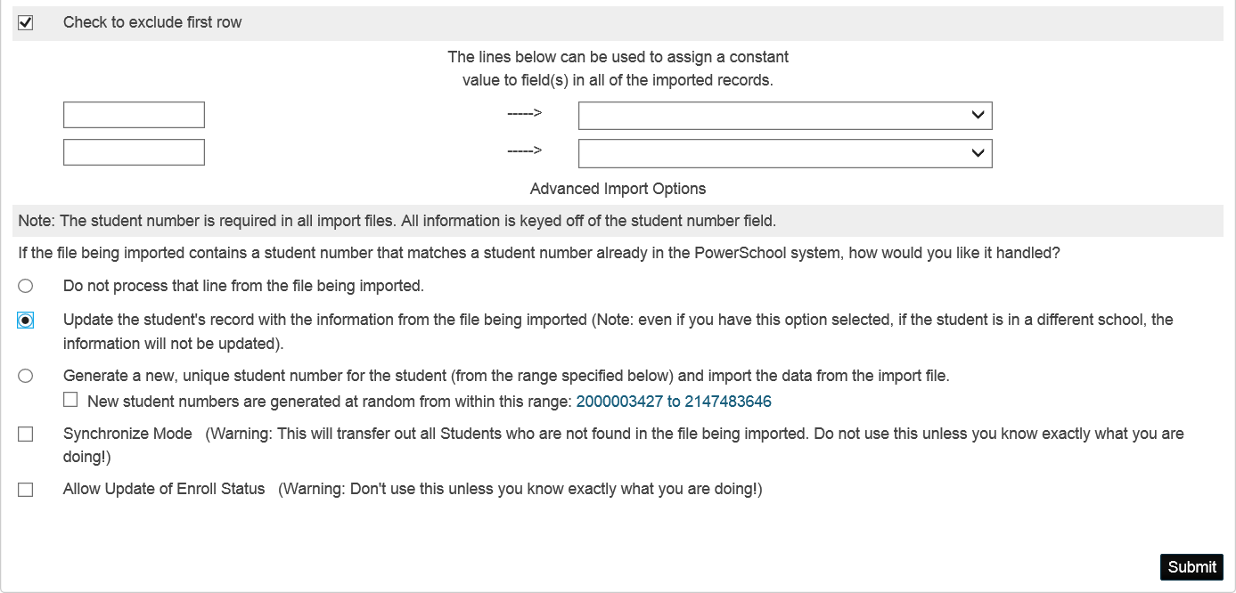

Import Records from an ASCII Text File
Fields will be automatically mapped
Check to exclude the first row: make sure this field is checked
Update the student’s record…: make sure this option is checked to update the student’s record
Submit

Once the import has completed, you may want to spot check a few students to make sure that there is data on the CRDC tab of the State/Province-MI page.

